**2025 – 2026 Advanced Placement Capstone Diploma Program Application  
  
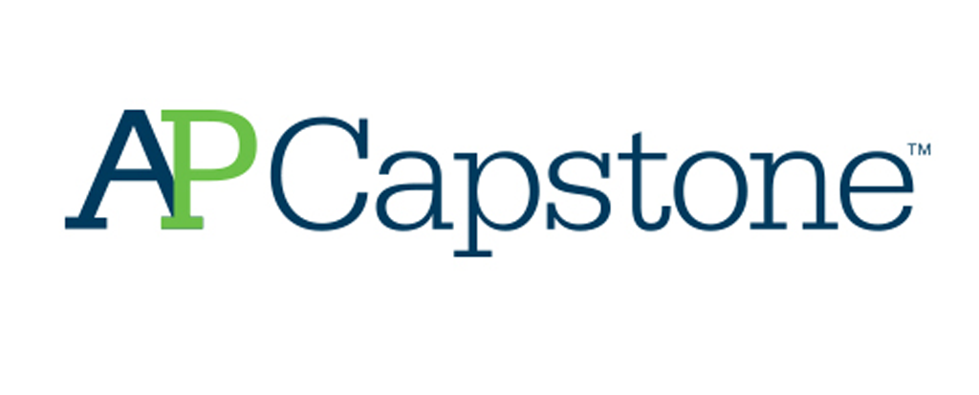**

**Thank you for your interest in the Capstone Diploma Program. Please complete all parts of the application thoroughly and carefully. Once completed, return the student portion of the application to Mr. Bassett (256), Mrs. Transue (258), or Mrs. Younghouse (221).**

**Application Deadline: Friday, January 31st**

**Student Name: _________________________________________________________(Please Print)**

**1. List the courses you plan to take next year. *Please note, it is the expectation that students enrolling in the Capstone Diploma Program will also enroll in AP Language and Composition/American Literature during their junior year. It is also the expectation that students will take the AP Seminar exam.**

Please list the courses you plan to take next year as a junior.

|  |  |
| --- | --- |
|  |  |
|  |  |
|  |  |
|  |  |

**Requirements of the Capstone Program:**

1. Concurrent enrollment in AP English Language and Composition/American Literature (11th) and AP English Literature and Composition (12th grade)
2. Students will not be permitted to drop any of the Capstone Diploma Courses once accepted.
3. The coursework for AP Seminar and AP Research is submitted to the Digital Portfolio and becomes part of the AP score for the class; therefore, students must take both exams.

**In signing below, I acknowledge that if accepted to the program, I agree to remain in the Capstone program during both junior and senior year. I also agree to register for and take both Capstone exams. I also understand that I must attend these classes F2F.**

Student Name (please print) _________________________________________

Parent signature _____________________________________________________

Student signature ____________________________________________________

# **AP Capstone Diploma Program**

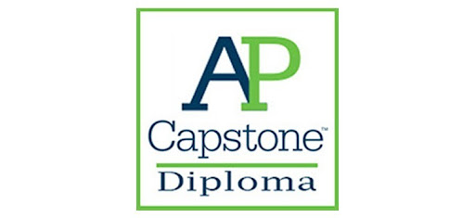

AP Capstone™ is a diploma program based on two AP courses: AP Seminar and AP Research.  
  
 These courses are designed to complement other AP courses that the AP Capstone student may take.  
 Instead of teaching specific subject knowledge, AP Seminar and AP Research use an interdisciplinary approach to develop the critical thinking, research, collaboration, time management, and presentation skills students need for college-level work.  
  
 Students at NFHS will take AP Seminar in grade 11, followed by AP Research in grade 12. Each course is yearlong, and AP Seminar is a prerequisite for AP Research.   
  
 Additionally, AP Language & Composition is a corequisite for AP Seminar. AP Literature or Dual Enrollment are corequisites for AP Research.  
  
 **In both courses, students investigate a variety of topics in multiple disciplines driven by their interests.  
 Both courses guide students through completing a research project, writing an academic paper, and making a presentation on their project.  
 Over the course of the two-year program, students are required to:**

○ **Analyze topics through multiple lenses to construct meaning or gain understanding.**

○ **Plan and conduct a study or investigation.**

○ **Propose solutions to real-world problems.**

○ **Plan and produce communication in various forms.**

○ **Collaborate to solve a problem.**

○ **Integrate, synthesize, and make cross-curricular connections.**

Students who earn scores of 3 or higher in AP Seminar and AP Research and on four additional AP Exams of their choosing receive the AP Capstone Diploma™.

For more information, visit collegeboard.org/apcapstone.

**AP CAPSTONE TEACHER RECOMMENDATION**

***Students: Please submit this form to one of your academic teachers.***

***Teachers: Please complete the form below and return to Mr. Bassett (256), Mrs. Transue (258), or Mrs. Younghouse (221) by Monday, January 31st. Note: please do not return your completed forms to the student.***

Student Name: ___________________________________________________________

Teacher Name: ___________________________________________________________

Course: ______________________________________

**Please use the 1-5 scale (1=poor; 5=excellent) to rate this student accordingly.**

|  |  |  |  |  |  |
| --- | --- | --- | --- | --- | --- |
|  | **1** | **2** | **3** | **4** | **5** |
| **Ability to Plan and Use Time Efficiently**  Student takes initiative and does not require supervision. |  |  |  |  |  |
| **Independent Work**  Student is willing to work independently, remain on task, and meet deadlines without prompting from teacher. |  |  |  |  |  |
| **Leadership Skills**  Student is a natural leader, often engaging others in thoughtful and insightful dialogue and influencing others positively |  |  |  |  |  |
| **Team Work Skills**  The student is a good supporter of others and enjoys helping classmates/teammates succeed. |  |  |  |  |  |
| **Written Communication Skills**  Student’s writing always contains an insightful and recognizable thesis, essential details, and valid support. The student is capable of employing a rich vocabulary. |  |  |  |  |  |
| **Oral Communication Skills**  Student is an articulate and compelling communicator. The student is capable of employing a rich vocabulary and can move people to action when applicable. |  |  |  |  |  |
| **Critical Thinking**  Student conclusions and related outcomes (consequences and implications) are logical and reflect student’s informed evaluation and ability to place evidence and perspectives discussed in priority order. |  |  |  |  |  |
| **Quality of Class Participation / Discussion**  Student is consistently engaged each day, asking questions that reflect an understanding of the material/performance. |  |  |  |  |  |
| **Intellectual Curiosity**  Student displays creative thought processes and/or original ideas, concepts and proposals that other students overlook. |  |  |  |  |  |

**Please include any other comments/observations that would help us to gain insight into this student’s intellectual curiosity, ability to think critically, and willingness to collaborate with others on meaningful and challenging projects.**